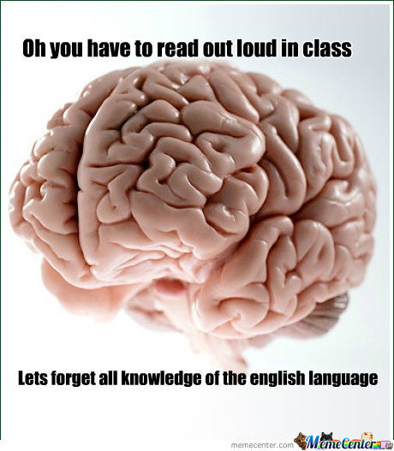
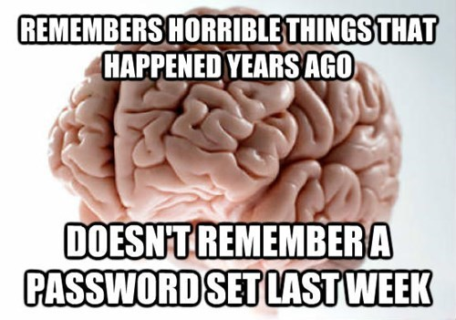
HOW DOES OUR BRAIN WORK?
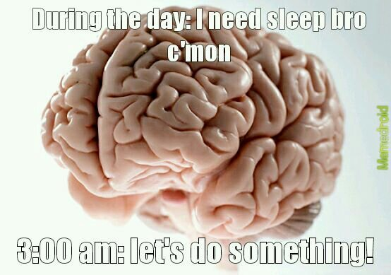
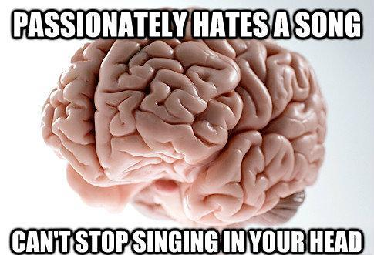

DISCUSS
1. Answer the question.
- Are those memes above on the mark? Are they accurate? Have you ever had such experience?
- Why is human’s brain a great topic for memes?
- What is the job of a brain?
- What would a map of the brain look like?
- What was the most important scientific discovery?
2. TEST YOURSELF. Try to guess which of the statements below are myths and which are facts. Justify your opinion.

Your brain does creative work better when you’re tired

Brain Damage Is Permanent

Your vision trumps all other senses.

Introversion and extroversion come from different wiring in the brain.

We tend to like people who make mistakes more.

Humans Have the Biggest Brains

Exercise can reorganize the brain and boost your willpower.

Brain Cells Die Permanently

You can make your brain think time is going slowly by doing new or repetitive things.

Drinking Alcohol Kills Brain Cells

Drugs create holes in your brain.

So-called 'aha!', ‘eureka’ moments are rare and random.

Male brains are more logical, female brains are more empathetic.

You're necessarily an "auditory" or a "visual" learner.

You only have 5 senses.

Stress can change the size of your brain (and make it smaller)

It is literally impossible for our brains to multi-task.

Naps improve your brain’s day to day performance

[Sourcre: https://buffer.com]
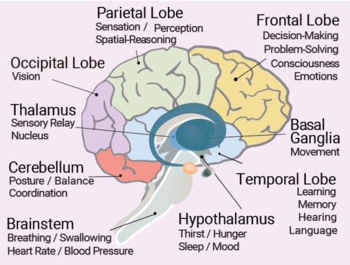
READING:

The brain does the thinking, learning, and feeling for the body. For humans, it is the source of consciousness.
The brain also controls basic autonomic body actions, like breathing, digestion, heartbeat, that happen automatically. The brain controls our thoughts, memory and speech, movement of the arms and legs, and the function of many organs within our body.
The central nervous system (CNS) is composed of the brain and spinal cord.
Your brain contains billions of nerve cells arranged in patterns that coordinate thought, emotion, behavior, movement and sensation. A complicated highway system of nerves connects your brain to the rest of your body, so communication can occur in split seconds. [Source:
www.mayoclinic.org]

WATCHING https://www.youtube.com/watch?v=o3yFSOeB5c4
Watch the video and answer the questions:

- “A small sliver” is a:
- fraction b) advantage c) silver piece
- Scientists didn’t have a big picture of what was going on in the nervous system.
- True b) False c) not mentioned
- Brain is:
- the most important part of neural activity b) the place of neural activity c) responsible for receiving information.
- The worm was taken into consideration, because:
- Similar to people b)easy to examine c) it was possible to study it in 1970s
- Contectomes is a:
- worm b) map of brain c) connections in brain
- Fluorescent calcium was used to:
- mark calcium ions b) mark calcium and iron c) create a map
- The software took numbers and “crunch” them to:
- calculate them once again b)build a 3D model c) get crunched
- Work done with worms could help us:
- work the same way with human’s brain b) get closer to understand how nervous system works c) use worms in medicine

