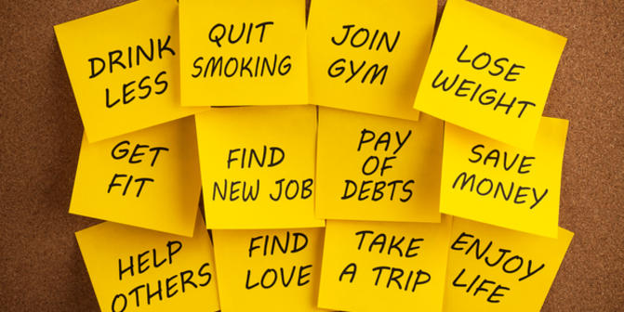
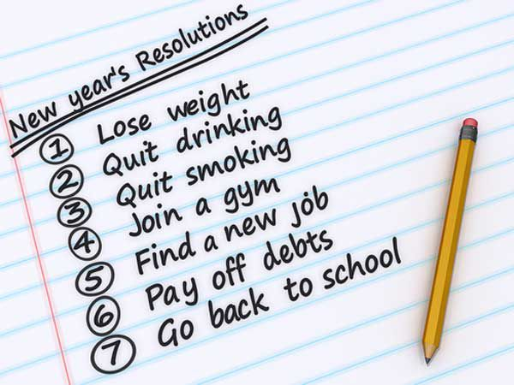
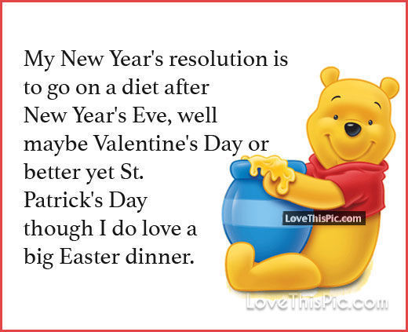
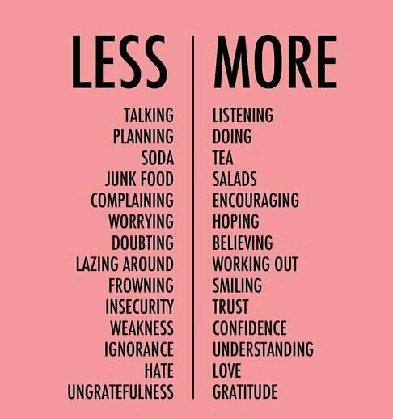
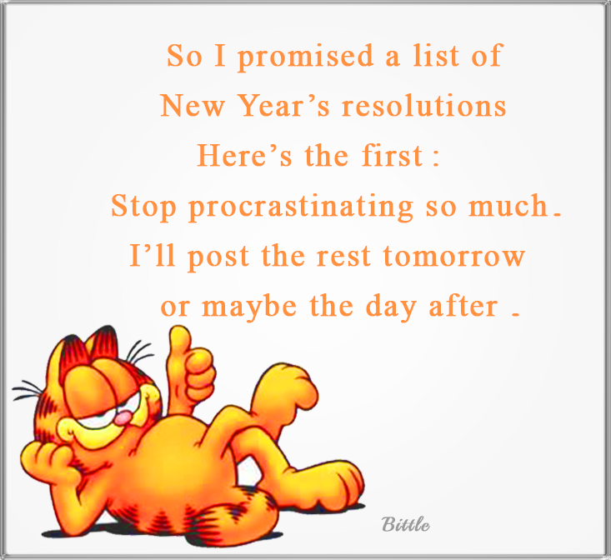
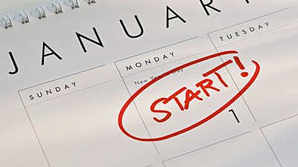
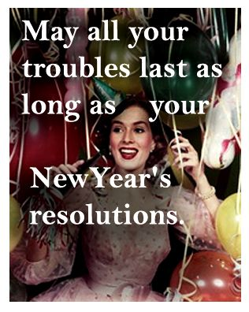

Watch the video and listen to the song: https://www.youtube.com/watch?v=vjPgs7S4Uc4
Fill the gaps with words below.
New Year’s Resolutions by KOIT

blood | shipments | guessed | glass
shins | underwear | pucks | nude

It's the time of year when we make resolutions
A time for you to find the right solutions
So listen up while I tell you what I'm gonna do
I'm gonna stop drinking ……….. (ba ba ba da dah)
I'm gonna start eating mud (ba ba ba da dah)
Gonna stop lining up the heads outside of my house
I'm gonna stop walking there (ba ba ba da dah)
In my French ………… (ba ba ba da dah)
Gonna start to be the man that I should be
It's New Year’s eve as I make my commitments
Promise to stop all those dildo ……………
So here are other things that I'm gonna do
I'm gonna stop loving sheep (ba ba ba da dah)
Gonna piss for a week (ba ba ba da dah)
Gonna stop leaving all those gifts outside of their house
I'm gonna start kicking ……….. (ba ba ba da dah)
Gonna stop raiding bins (ba ba ba da dah)
Gonna start to be the man that I should be
I'm Gonna stop stalking ducks (ba ba ba da dah)
I'm gonna start throwing ……….. (ba ba ba da dah)
Gonna stop sending ………. selfies to the Queen
I'm gonna swim with a turd (ba ba ba da dah)
Gonna always eat third (ba ba ba da dah)
Gonna send my arm through customs in a jar
I'm gonna start blowing ……….. (ba ba ba da dah)
You've ………….. it, right from my ass (ba ba ba da dah)
Gonna start to be the man that I should be
It's the time of year when we make resolutions

Discuss the difference between given words. How do we use them? Why?
Solution resolution
RESOLUTUIN
SOLUTION

Study sentences below. Focus on contractions. What do they stand for?
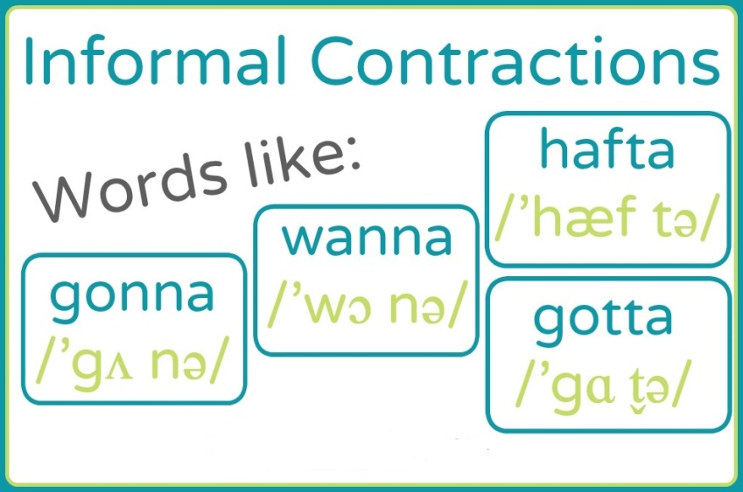
I gonna stop eating mud. I gonna stop drinking blood.
I wanna start my new life this year.
I hafta go.
Gonna = be going to
Wanna = want to
HAFTA = have to
We use them in spoken English, mostly in AmE in order to make our sentence shorter without changing the tense. There are of course a few more contractions in colloquial English.
To find out more check it out: https://www.youtube.com/watch?v=G91iD7og9bY (Gonna Wanna Tonight by Chase Rice)
Practice your own sentences using given contractions. For example talk about thing which you gonna do next year/month/week/day.
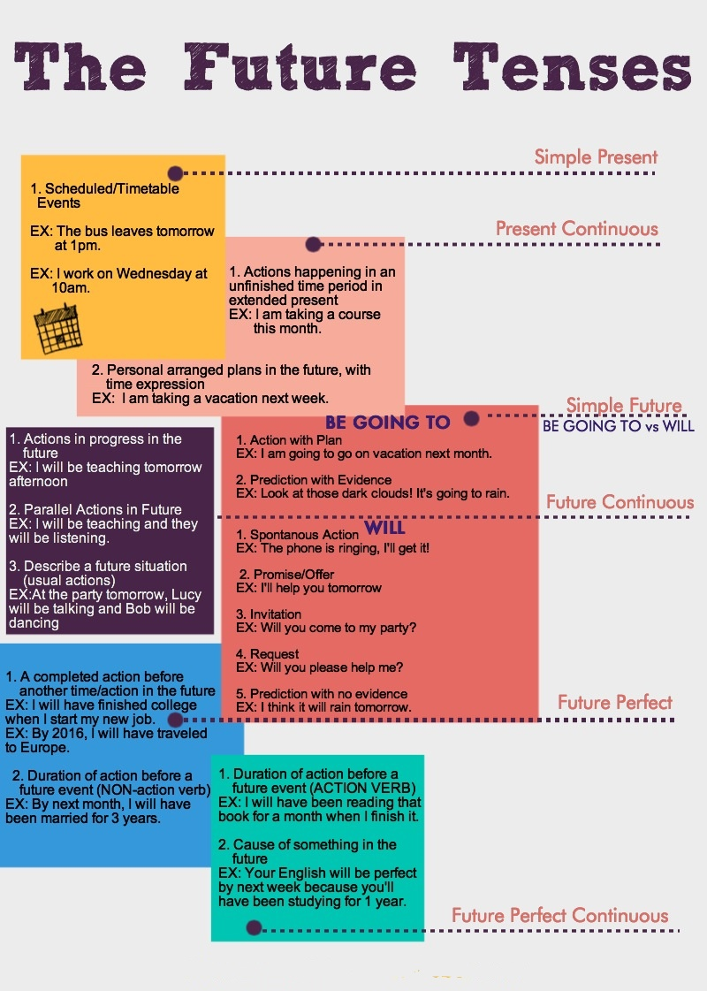
Remember! You can also have a lot of different options to express future
New Year’s Resolution is a promise to oneself hence the structures with “will” are usually the most appropriate. Finish sentences below writing down 5 ideas/plan for a next year.
1. I will
2. I will not
3. I will be
4. I will have
5. I will have been

